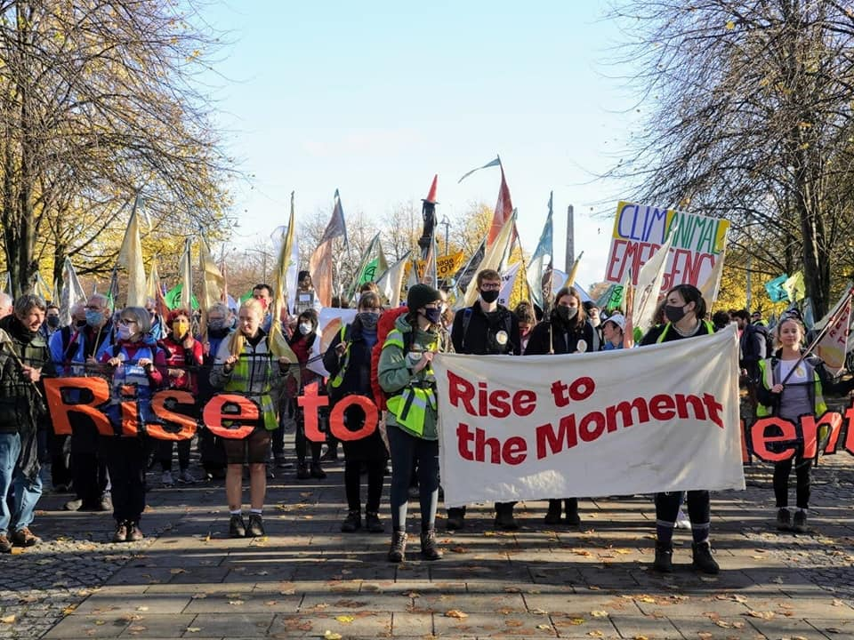

**Rachel Mander, Christian – Young Christian Climate Network**

**Why do you care for the earth?**

I remember learning that climate change would increase the number of people in poverty by several hundred million within a decade, and suddenly realising how connected people’s livelihoods were to the stability of the earth. I then saw how precious the earth was, and how much danger we are in as we irreversibly change entire regions and make them uninhabitable.

**How has your faith inspired your action on climate change and environmental issues?**

When I read the Bible, I encounter a God who cares for every living thing. Colossians 1:20 tells us that Jesus’ death was to save all things, “whether things on earth or things in heaven, by making peace through the blood of His cross.” As a Christian I follow the two greatest commandments: to love God and to love my neighbour as Jesus did. I cannot love God while rejecting or destroying what God has made on earth, and loving my ‘neighbour’ means loving every living thing, which, like me, is in the care of God. Climate change and other environmental issues threaten what God has made and lives, and my faith inspires me to act as an expression of love against these threats.

**What do you do to put these beliefs into action?**

I have made personal decisions about my own life – becoming vegetarian / vegan in what I eat, deciding not to ever fly on an aeroplane, making sure I never invest money in fossil fuels. I also join in campaigning actions, such as speaking at the board meetings of companies to ask them about how they are responding to climate risk and organising campaign actions with YCCN (Young Christian Climate Network).

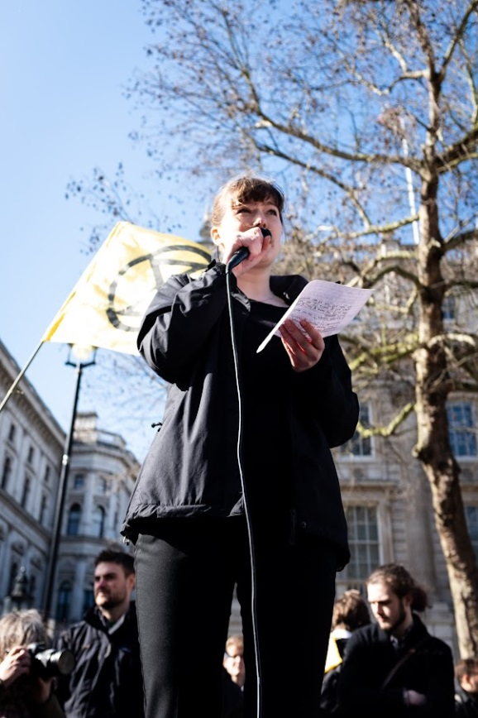

**The YCCN ‘Rise to the Moment’ campaign, for the COP26 climate conference**

**Rachel speaking at an Extinction Rebellion (XR) event**